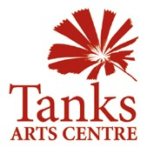PO Box 359 Cairns Q 4870
46 Collins Ave, Edge Hill Q 4870 www.tanksartscentre.com
P: 07 4032 6609 F: 07 4032 2610 info@tanksartscentre.com

Tanks Multi-Arts Residency Program

Introduction
The Tanks Arts Centre and Botanic Gardens precinct is unique. No other facility in the world presents to the creative mind the same palette of physical, historical, cultural and environmental attributes. The multi-arts residency program is designed to stimulate a creative response to these attributes from artists, communities and visitors.
Artworks and projects produced and presented at The Tanks and Botanic Gardens should interpret and amplify the significance of the precinct, the city of Cairns and the people who live here, our cultures, our environment, our place in the region and our relationship with the rest of the world.

Key Themes
To help direct the development of the program, 7 key themes are identified. Initiatives by communities, artists and the Tanks should respond to one or more of these themes.

1. Nature/Natural Heritage/Indigenous Flora & Fauna
2. Indigenous Cultures
3. Asia Pacific Region
4. North Queensland Region
5. Local Communities and community issues
6. Local Industry
7. Local History

Initiatives
Artists and arts workers are invited to present project ideas that respond to the vision and themes of the Tanks & Botanic Gardens. Proposals for residencies, exhibitions and events are assessed against the following criteria, but need not meet them all:
1. The project and the work should have a high degree of collaboration. This may be between artists with each other, between artist and communities or between artists and professionals in other disciplines such as science, natural history and cultural heritage.
2. Projects that involve a high level of creative engagement are encouraged. Communities and audiences may be involved in the work through participating in production or interacting with the product in a way that enriches the work.
3. Projects that respond to the site in an innovative way are encouraged. Works may be site specific, or designed to locate and relocate around the buildings and grounds of the precinct.
4. Proposals should consider innovative ways of extending the life and accessibility of the work beyond the period of project.
5. Projects that offer a potential for generating income for the artists are supported.

Proposals may be developed in consultation with the Tanks Curator and/or the Program and Events Coordinator and will be assessed internally. Successful applications can expect support from the Tanks including:
• Curatorial Services
• Assistance with raising funds to support the project
• Studio/production space
• Exhibition or performance space
• Promotional support
• Handling of ticket sales and sales of artworks
• Accommodation

Partnerships
Many residencies at the Tanks Arts Centre involve partnerships with other arts and community organisations in Cairns. These include:
Cairns Botanic Gardens, who offer access to an enormous collection tropical species, scientific and cultural knowledge and connections to researchers and academics in the plant world.
KickArts Contemporary Arts Centre, who also run a residency program and a fully operational printmaking studio, Djumbunji Press http://kickarts.org.au/
Creative Partnerships is a unit of Cairns Regional Council which manages innovative and creative collaborations and initiatives to best service the community needs.
http://www.cairns.qld.gov.au/facilities-and-recreation/arts-culture/creative-partnerships

Note
The Tanks Arts Centre is a multi-arts venue and as such, there will undoubtedly be times when other projects and events are occurring concurrently, often in the same space. Tanks staff takes care to ensure that multiple bookings are advantageous to one another and will inform artists’ in residence of other projects and events running concurrently with their project. Tanks view this continual crossover of audiences to be an advantage to artists’ in residence, exhibitors, performers, and to the larger community.

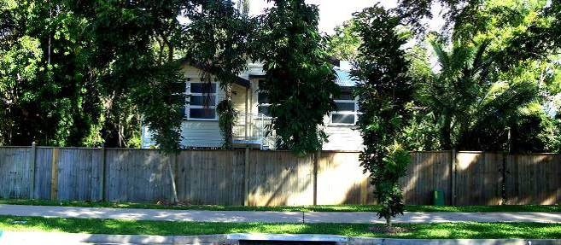

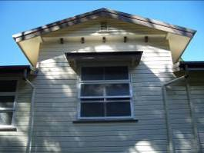No. 5 Collins Avenue, Edge Hill is a four bedroom timber house, built in the traditional “Queenslander” architectural, style with a large deck at the back and a lush garden. It includes an office/studio with telephone and wireless internet upstairs and a workroom downstairs. It can sleep up to 5 people as a family or in a share-house situation. It is in walking distance from the Tanks Arts Centre and adjoins the beautiful Centenary Lakes parkland.

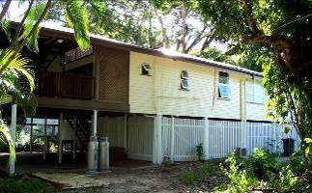

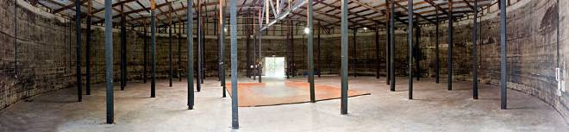

Tank 3: The only Tank completely devoid of internal partitioning, Tank 3 is an empty shell offering the greatest flexibility of all the spaces for positioning of table setup (seats 350) and staging. Circus rigging is an additional characteristic of this tank.

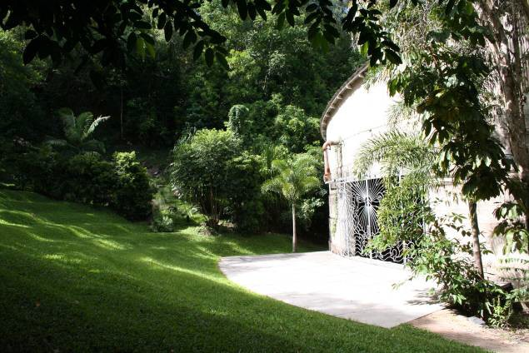

Amphitheatre: Tanks outdoor amphitheatre is a lush alternative for performing arts, encircled as it is by dense rainforest and rocky escarpment. The space caters for an audience of 100, all seated on a stepped grass slope that falls away to the stage area at the front doorstep of Tank 3.

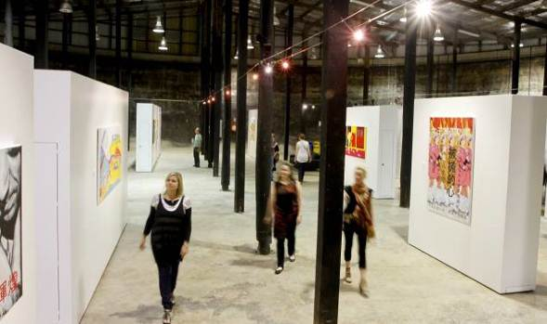

Tank 4: A flexible exhibition space; Tank 4 contains a flexible gallery area which can be utilised as one large space, or sectioned into a long gallery and two or three smaller corner galleries or artist studio spaces by use of movable display walls. Tank 4 offers moveable bar infrastructure, refrigeration and an incomparable ambience for a small function (max 150 people).

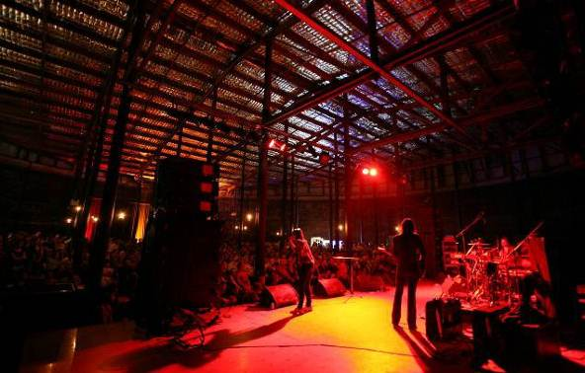

Tank 5: One of the most highly distinctive and dynamic performance spaces in the country, Tank
5, has a licensed bar and standing capacity of 600 (seated 400). The rugged, old oil-stained poles and sheer concrete walls imbue the venue with a gothic charm. Tank 5 is a standout
performance venue with clear acoustics, and relaxed mood, in an iconic setting. It has theatre style lighting, a green room, sprung dance floor / stage and moveable bar facilities.

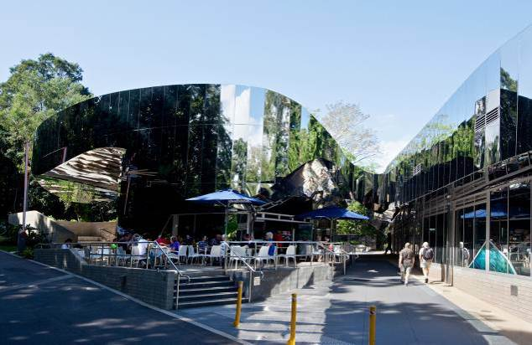

Cairns Botanic Gardens and Visitor Centre: Artists in residence who wish to gain access to horticultural expertise, advice and the botanical collection of the gardens will be co-hosted by the Cairns Botanic Gardens http://www.cairns.qld.gov.au/cbg

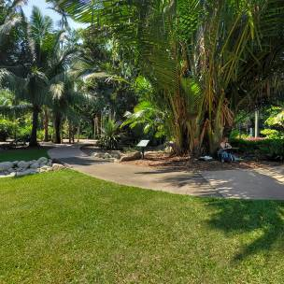

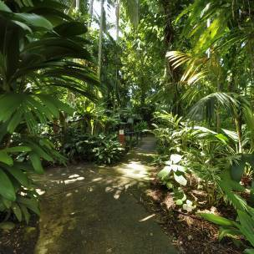Cairns Botanic Gardens and Visitor Centre: Artists in residence who wish to gain access to horticultural expertise, advice and the botanical collection of the gardens will be co-hosted by the Cairns Botanic Gardens http://www.cairns.qld.gov.au/cbg

Fees Schedule

Residencies |  |  | Rate
Studio space | At Tanks Arts Centre (per artist) | Per week | $87.35
Residency Accommodation | Per room/person. | Per week | $138.75
Residency Accommodation | Whole house (max 5 people). | Per week | $231.20

A minimum of 2 weeks will be charged for short stays.

For information about exhibition costs, please visit:
http://www.tanksartscentre.com/home/inner.asp?PageID=87

For information on venue and equipment hire costs, please contact Tanks Arts Centre on +61 7
4032 6600 or info@tanksartscentre.com, alternately you can download the venue specifications/
hire rates/ quick facts sheet on the website: www.tanksartscentre.com

A full list of Tanks Arts Centre’s fees and charges is found here:
http://www.cairns.qld.gov.au/about-council/rates,-fees-and-charges/fees-and-charges

Any waiving of fees and charges can be granted through Cairns Regional Council’s In-Kind
Grants Program, for more information please visit:

http://www.cairns.qld.gov.au/
data/assets/pdf_file/0012/11721/ACInKind.pdf

Projects that are initiated by the Tanks in partnerships with artists or community organisations may be exempt from fees and charges.

PO Box 359 Cairns Q 4870
46 Collins Ave, Edge Hill Q 4870 www.tanksartscentre.com
P: 07 4032 6609 F: 07 4032 2610
info@tanksartscentre.com

MULTI-ARTS RESIDENCY APPLICATION FORM

Project/Exhibition name | Click here to enter text.
Applicant’s name | Click here to enter text.
Organisation | Click here to enter text.
Address | Click here to enter text.
Ph/Mobile | Click here to enter text.
Email | Click here to enter text.

Are you:
An artist (please provide CV and photographs of examples of your work)
A group of artists (please provide CVs or a group resume with examples of work)
Are you partnering this project with anyone else? If so, please describe the partnership.
Click here to enter text.

Who is financing, sponsoring or funding your project?

Click here to enter text.

Do you require accommodation? Yes No
If yes, please indicate dates in the table below. Guidelines for No.5 Collins Avenue residency accommodation are available on-line, but there is no requirement for a separate application form.
http://www.tanksartscentre.com/home/inner.asp?PageID=112

What do you want to do during your residency?

Click here to enter text.

How long will your residency be?
Click here to enter text.

Please indicate how many hours or days per week you will need to spend at the Tanks.

Click here to enter text.

Please provide a rough timetable showing different stages of the residency (attach if necessary).

ACTIVITY | DATES
Click here to enter text. | Click here to enter text.
Click here to enter text. | Click here to enter text.
Click here to enter text. | Click here to enter text.
Click here to enter text. | Click here to enter text.

Please indicate whether there would be a presentation outcome at Tanks:
Tank 4
Tank 5
Tank 3
Other – please specify eg. fig tree, amphitheatre etc..

What else will you need? (Include tech sheet for audio equipment, furniture, access times etc)

Click here to enter text.

9 #2432877

