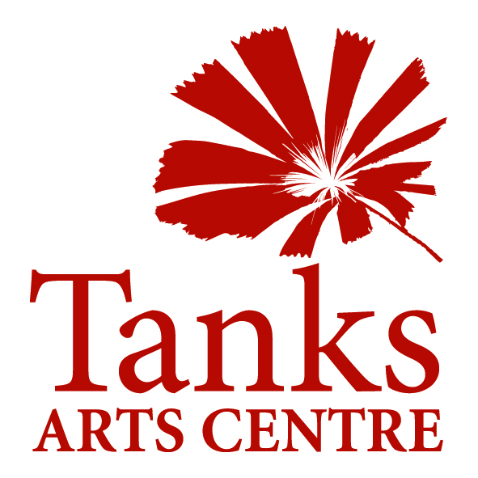
PO Box 359 Cairns Q 4870
46 Collins Ave, Edge Hill Q 4870
www.tanksartscentre.com
P: 07 4032 6609 F: 07 4032 2610
info@tanksartscentre.com

Cairns Sister Cities Artists’ Residency Exchange Program

Introduction
Cairns has sister city relationships with seven cities around the world. In the spirit of cultural exchange, our city offers this residency exchange program, for our local artists to visit and work in our sister cities and for artists in those cities to visit and work in Cairns. These guidelines and application form are for artists living in:
Oyama - Japan
Minami - Japan
Riga - Latvia
Sidney - British Columbia, Canada
Lae - Papua New Guinea
Scottsdale - USA
Zhanjiang – China

The Tanks Arts Centre is owned and operated by the Cairns Regional Council. It is a multi-arts venue and runs a multi-arts residency program, which offers:
- Studio or production space within the Tanks Arts Centre
- Accommodation in a four bedroom house, walking distance from the Tanks Arts Centre
- Presentation space within the Tanks Arts Centre or the botanic gardens

The Tanks Arts Centre is situated within the Cairns Botanic Gardens. Converted from three giant, concrete WWII oil storage tanks, no other facility in the world presents to the creative mind the same palette of physical, historical, cultural and environmental attributes. The multi-arts residency program is designed to stimulate a creative response to these attributes from artists, communities and visitors.
Artworks and projects produced and presented through the residency program should interpret and amplify the significance of the precinct, the city of Cairns and the people who live here, our cultures, our environment, our place in the region and our relationship with the rest of the world.
The Sister Cities Artists’ Residency Exchange Program reflects a partnership with the Cairns Regional Council Sister City Advisory Committee.

Criteria
Residency proposals are welcome from visual artists, musicians, performers, writers, new media artists, curators and other arts and cultural workers. Proposals will be assessed against the following criteria, but need not meet them all:
- The project aims should include increasing awareness and understanding between the peoples of our cities.
- The project and the work should have a high degree of collaboration. This may be between artists with each other, between artist and communities or between artists and professionals in other disciplines such as science, natural history and cultural heritage.
- Projects that involve a high level of creative engagement are encouraged. Communities and audiences may be involved in the work through participating in production or interacting with the product in a way that enriches the work.
- Projects that respond to the site in an innovative way are encouraged. Works may be site specific, or designed to locate and relocate around the buildings and grounds of the Tanks and Botanic Gardens.
- Proposals should consider innovative ways of extending the life and accessibility of the work beyond the period of project.

Application Process
Correspondence with Tanks Arts Centre staff is encouraged at any time during the process. Applications must be lodged initially with the Tanks Arts Centre. Project ideas will then be developed in consultation with the Tanks Curator and/or the Program and Events Coordinator with reference to the Cairns Regional Council Sister City Committee where required. This is to ensure the viability of the project in the venue, establish the costs involved in delivering the project and develop funding strategies together with the applicant. The Tanks Arts Centre will present fully developed project proposals to the Cairns Regional Council Sister City Committee. Successful applicants will be offered a residency contract with Tanks Arts Centre.
Successful applications can expect support from the Tanks Arts Centre including:
- Professional programming and curatorial assistance
- Introduction to other organisations in Cairns who can assist with the project
- Studio/production space
- Exhibition and/or performance space
- Promotional support
- Handling of ticket sales and sales of artworks
- Accommodation

Accommodation
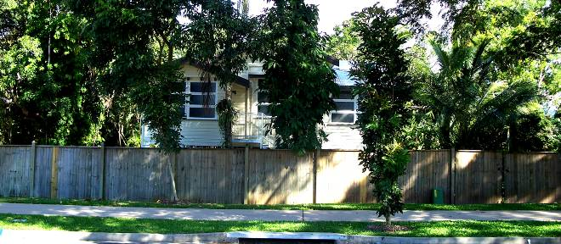

No. 5 Collins Avenue, Edge Hill is a four bedroom timber house, built in the traditional “Queenslander” architectural, style with a large deck at the back and a lush garden. It includes an office/studio with telephone and wireless internet upstairs and a workroom downstairs. It can sleep up to 5 people as a family or in a share-house situation. It is in walking distance from the Tanks Arts Centre and adjoins the beautiful Centenary Lakes parkland.

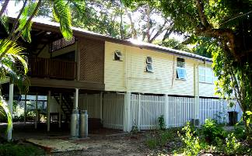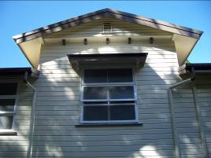

Venues
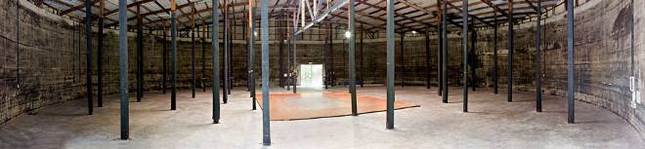
Tank 3: The only Tank completely devoid of internal partitioning, Tank 3 is an empty shell offering the greatest flexibility of all the spaces for positioning of table setup (seats 350) and staging. Circus rigging is an additional characteristic of this tank.

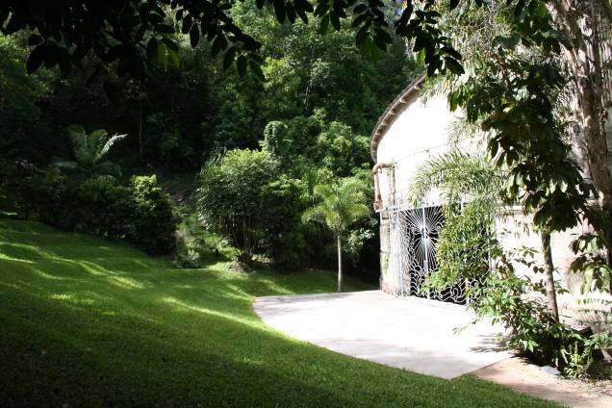
Amphitheatre: Tanks outdoor amphitheatre is a lush alternative for performing arts, encircled as it is by dense rainforest and rocky escarpment. The space caters for an audience of 100, all seated on a stepped grass slope that falls away to the stage area at the front doorstep of Tank 3.

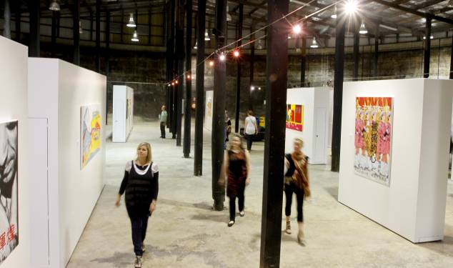
Tank 4: A flexible exhibition space. Tank 4 contains a flexible gallery area which can be utilised as one large space, or sectioned into a long gallery and two or three smaller corner galleries or artist studio spaces by use of movable display walls. Tank 4 offers moveable bar infrastructure, refrigeration and an incomparable ambience for a small function (max 150 people).

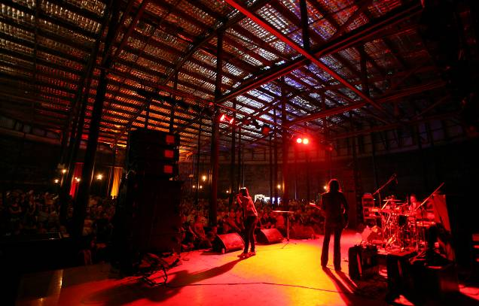
Tank 5: One of the most highly distinctive and dynamic performance spaces in the country, Tank 5, has a licensed bar and standing capacity of 600 (seated 400). The rugged, old oil-stained poles and sheer concrete walls imbue the venue with a gothic charm. Tank 5 is a standout performance venue with clear acoustics, and relaxed mood, in an iconic setting. It has theatre style lighting, a green room, sprung dance floor / stage and moveable bar facilities.

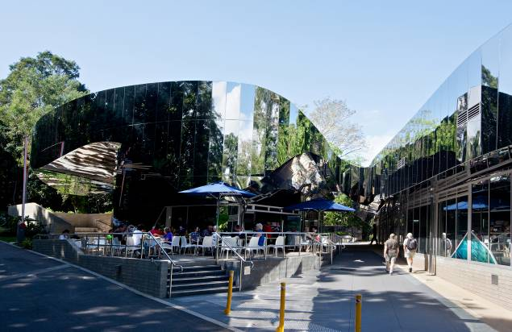

Cairns Botanic Gardens and Visitor Centre: Artists in residence who wish to gain access to horticultural expertise, advice and the botanical collection of the gardens will be co-hosted by the Cairns Botanic Gardens http://www.cairns.qld.gov.au/cbg

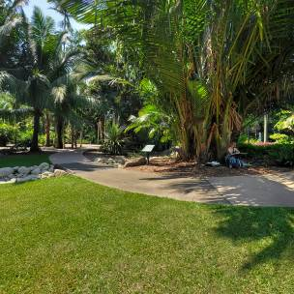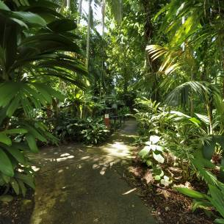

PO Box 359 Cairns Q 4870
46 Collins Ave, Edge Hill Q 4870
www.tanksartscentre.com
P: 07 4032 6609 F: 07 4032 2610
info@tanksartscentre.com

SISTER CITY RESIDENCY APPLICATION FORM

Project name
Applicant’s name
Organisation
Address
Ph/Mobile
Email

Are you:
An artist (please provide CV and photographs of examples of your work)
A group of artists (please provide CVs or a group resume with examples of work)

Please tell us about yourself and your arts practice in a few paragraphs.

What do you want to do during your residency?

Why do you wish to visit Cairns?

Are you partnering this project with anyone else? If so, please describe the partnership.

Who is financing, sponsoring or funding your project?

How long will your residency be?

Please indicate how many hours or days per week you will need to spend at the Tanks Arts Centre.

Please provide a rough timetable showing different stages of the residency (attach if necessary).
ACTIVITY | DATES

Please indicate whether you expect a presentation outcome at the Tanks Arts Centre and describe (e.g. exhibition, performance, workshops):

What else will you need? Include any equipment, furniture, technical support, assistance from other organisations…

Please submit this application to:

info@tanksartscentre.com
Tanks Arts Centre
Cairns Regional Council
PO Box 395
Cairns
Qld 4870

For more information, please contact:

Chris Stannard
Curator, Tanks Arts Centre
c.stannard@cairns.qld.gov.au
+617 4032 6609

or

Roz Pappalardo
Program and Events Coordinator
r.pappalardo@cairns.qld.gov.au
+617 4032 6605

